**2.4 GHz Low Noise Amplifier**

* 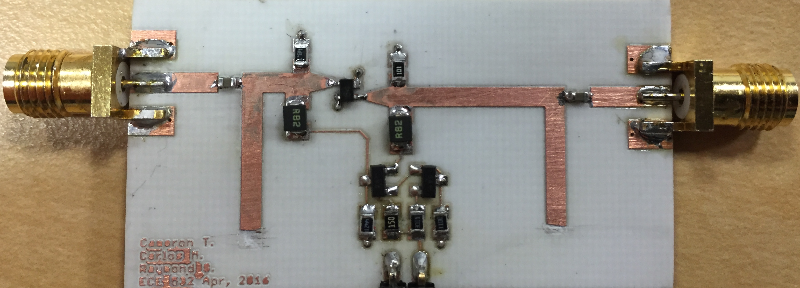13.7 dB gain
* -17.58 dB Input return loss
* -7.59 dB Output return loss
* 2.88 dB Noise Figure
* 3.3 V, 70mA
* 50 Ω I/O impedance

**Abstract**

The goal of this project is to design a 2.4 GHz Low Noise Amplifier (LNA) to meet or improve the specifications given below. The design methodology is as follows: we began by simulating and testing the DC bias circuit. Having decided on a DC operating point the RF portion of the circuit has simulated using ADS. Multiple iterations of the design were built using a double-sided Rogers RO4000® Laminates.

**Table 1 LNA requirements**

|  |  |
| --- | --- |
| Transistor: SAV-541+ | Frequency range =2.4-2.6 GHz |
| Gain >10 dB | Noise Figure <2.5 dB |
| Input Return Loss >10 dB | Output Return Loss <10dB |
| Supply Voltage 3.3V | Supply Current <100mA |

**DC Bias Circuit**

The DC bias circuit was provided by the reference design in the SAV-541+ datasheet shown in Figure 1.

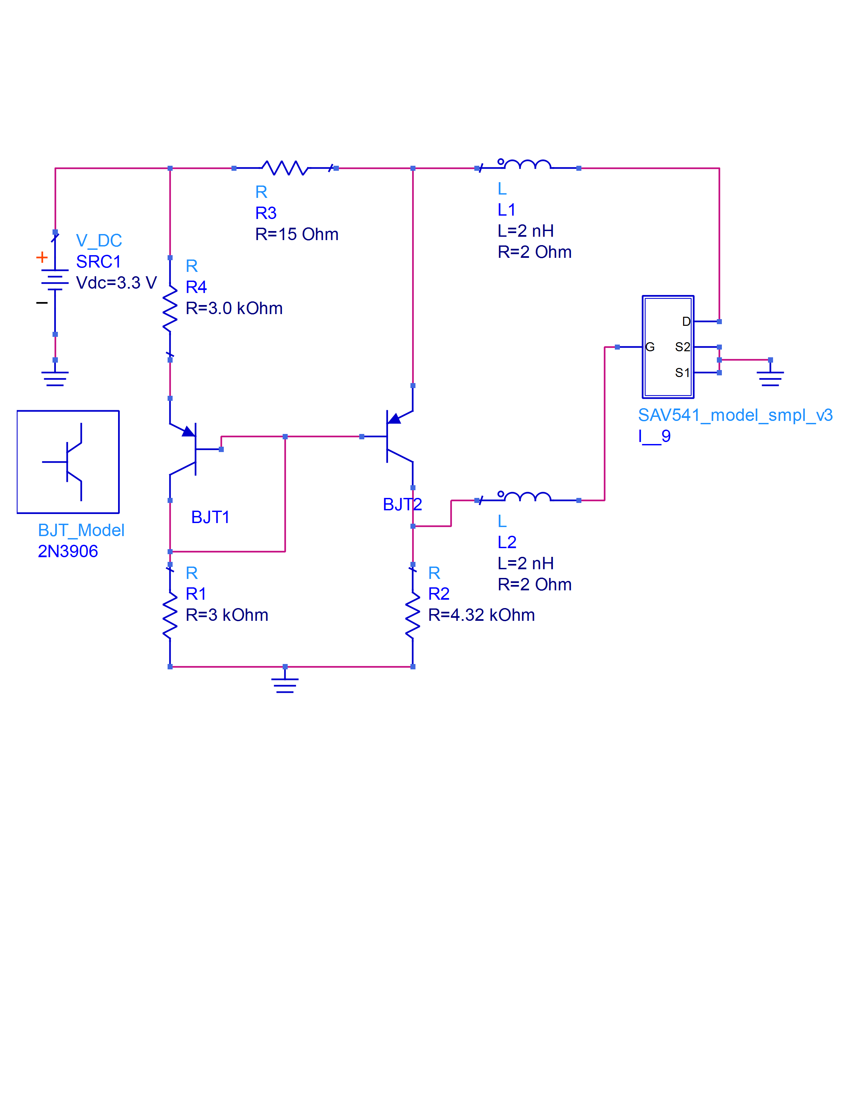

Figure 1 DC bias circuit

This active DC circuit is a current mirror, which provides stable drain and gate voltages to the SAV-541+. This active topology offers voltage stability due to reference current set by BJT1. This reference current is independent from the load presented by the gate or drain of the amplifier. This active circuit is also temperature independent although it is not important for this design since heat is not an issue.

Per the datasheet the gain and noise figure of the amplifier is not strongly dependent on bias voltage/current. In order to keep DC power dissipation low and to meet specs, the DC operating point is set to Vd~2V and Ids~60mA.

**RF Design**

Stabilizing the amplifier

In order to guarantee stability certain conditions must be meet. Using ADS amplifier “Design Guide” and with the S2P files provided by the manufacturer we were able to simulate stability, gain, noise circles. In order to unconditionally stabilize the amplifier from 100 MHz to 6GHz resistors in shunt where added to the gate and drain of the transistor. Adding these resistors increased stability while decreasing gain.

Simulating Stability and gain

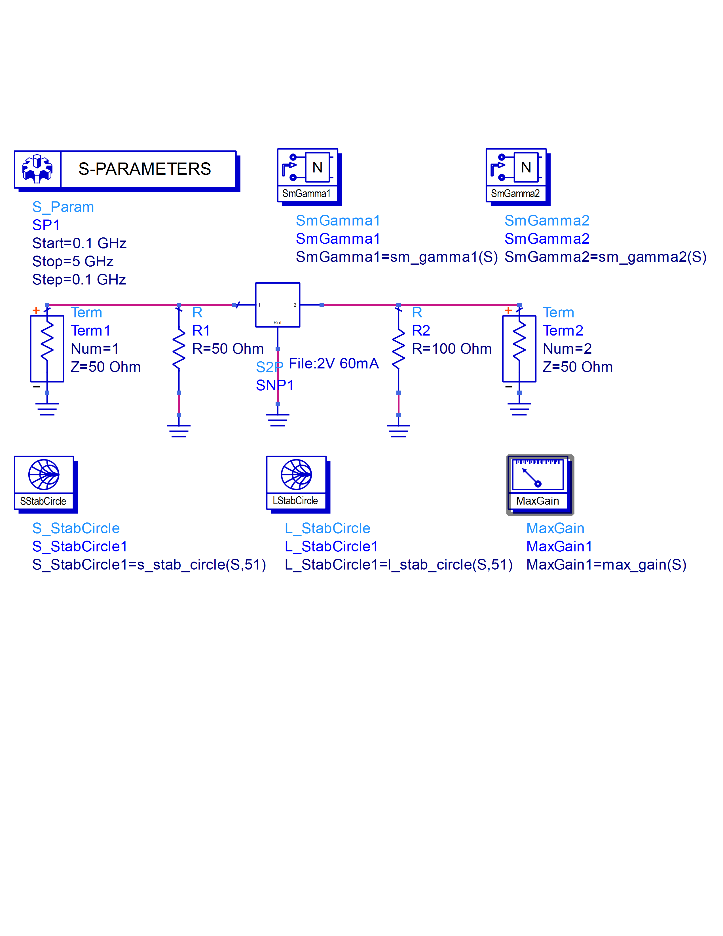

Figure 2 Stability and gain simulation schematic

As shown in Figure 2, 50 and 100 Ω resistors were used to unconditionally stabilize the transistor. Running an AC analysis in ADS it is shown that this topology produces stability circles outside the Smith chart, hence unconditional stability.

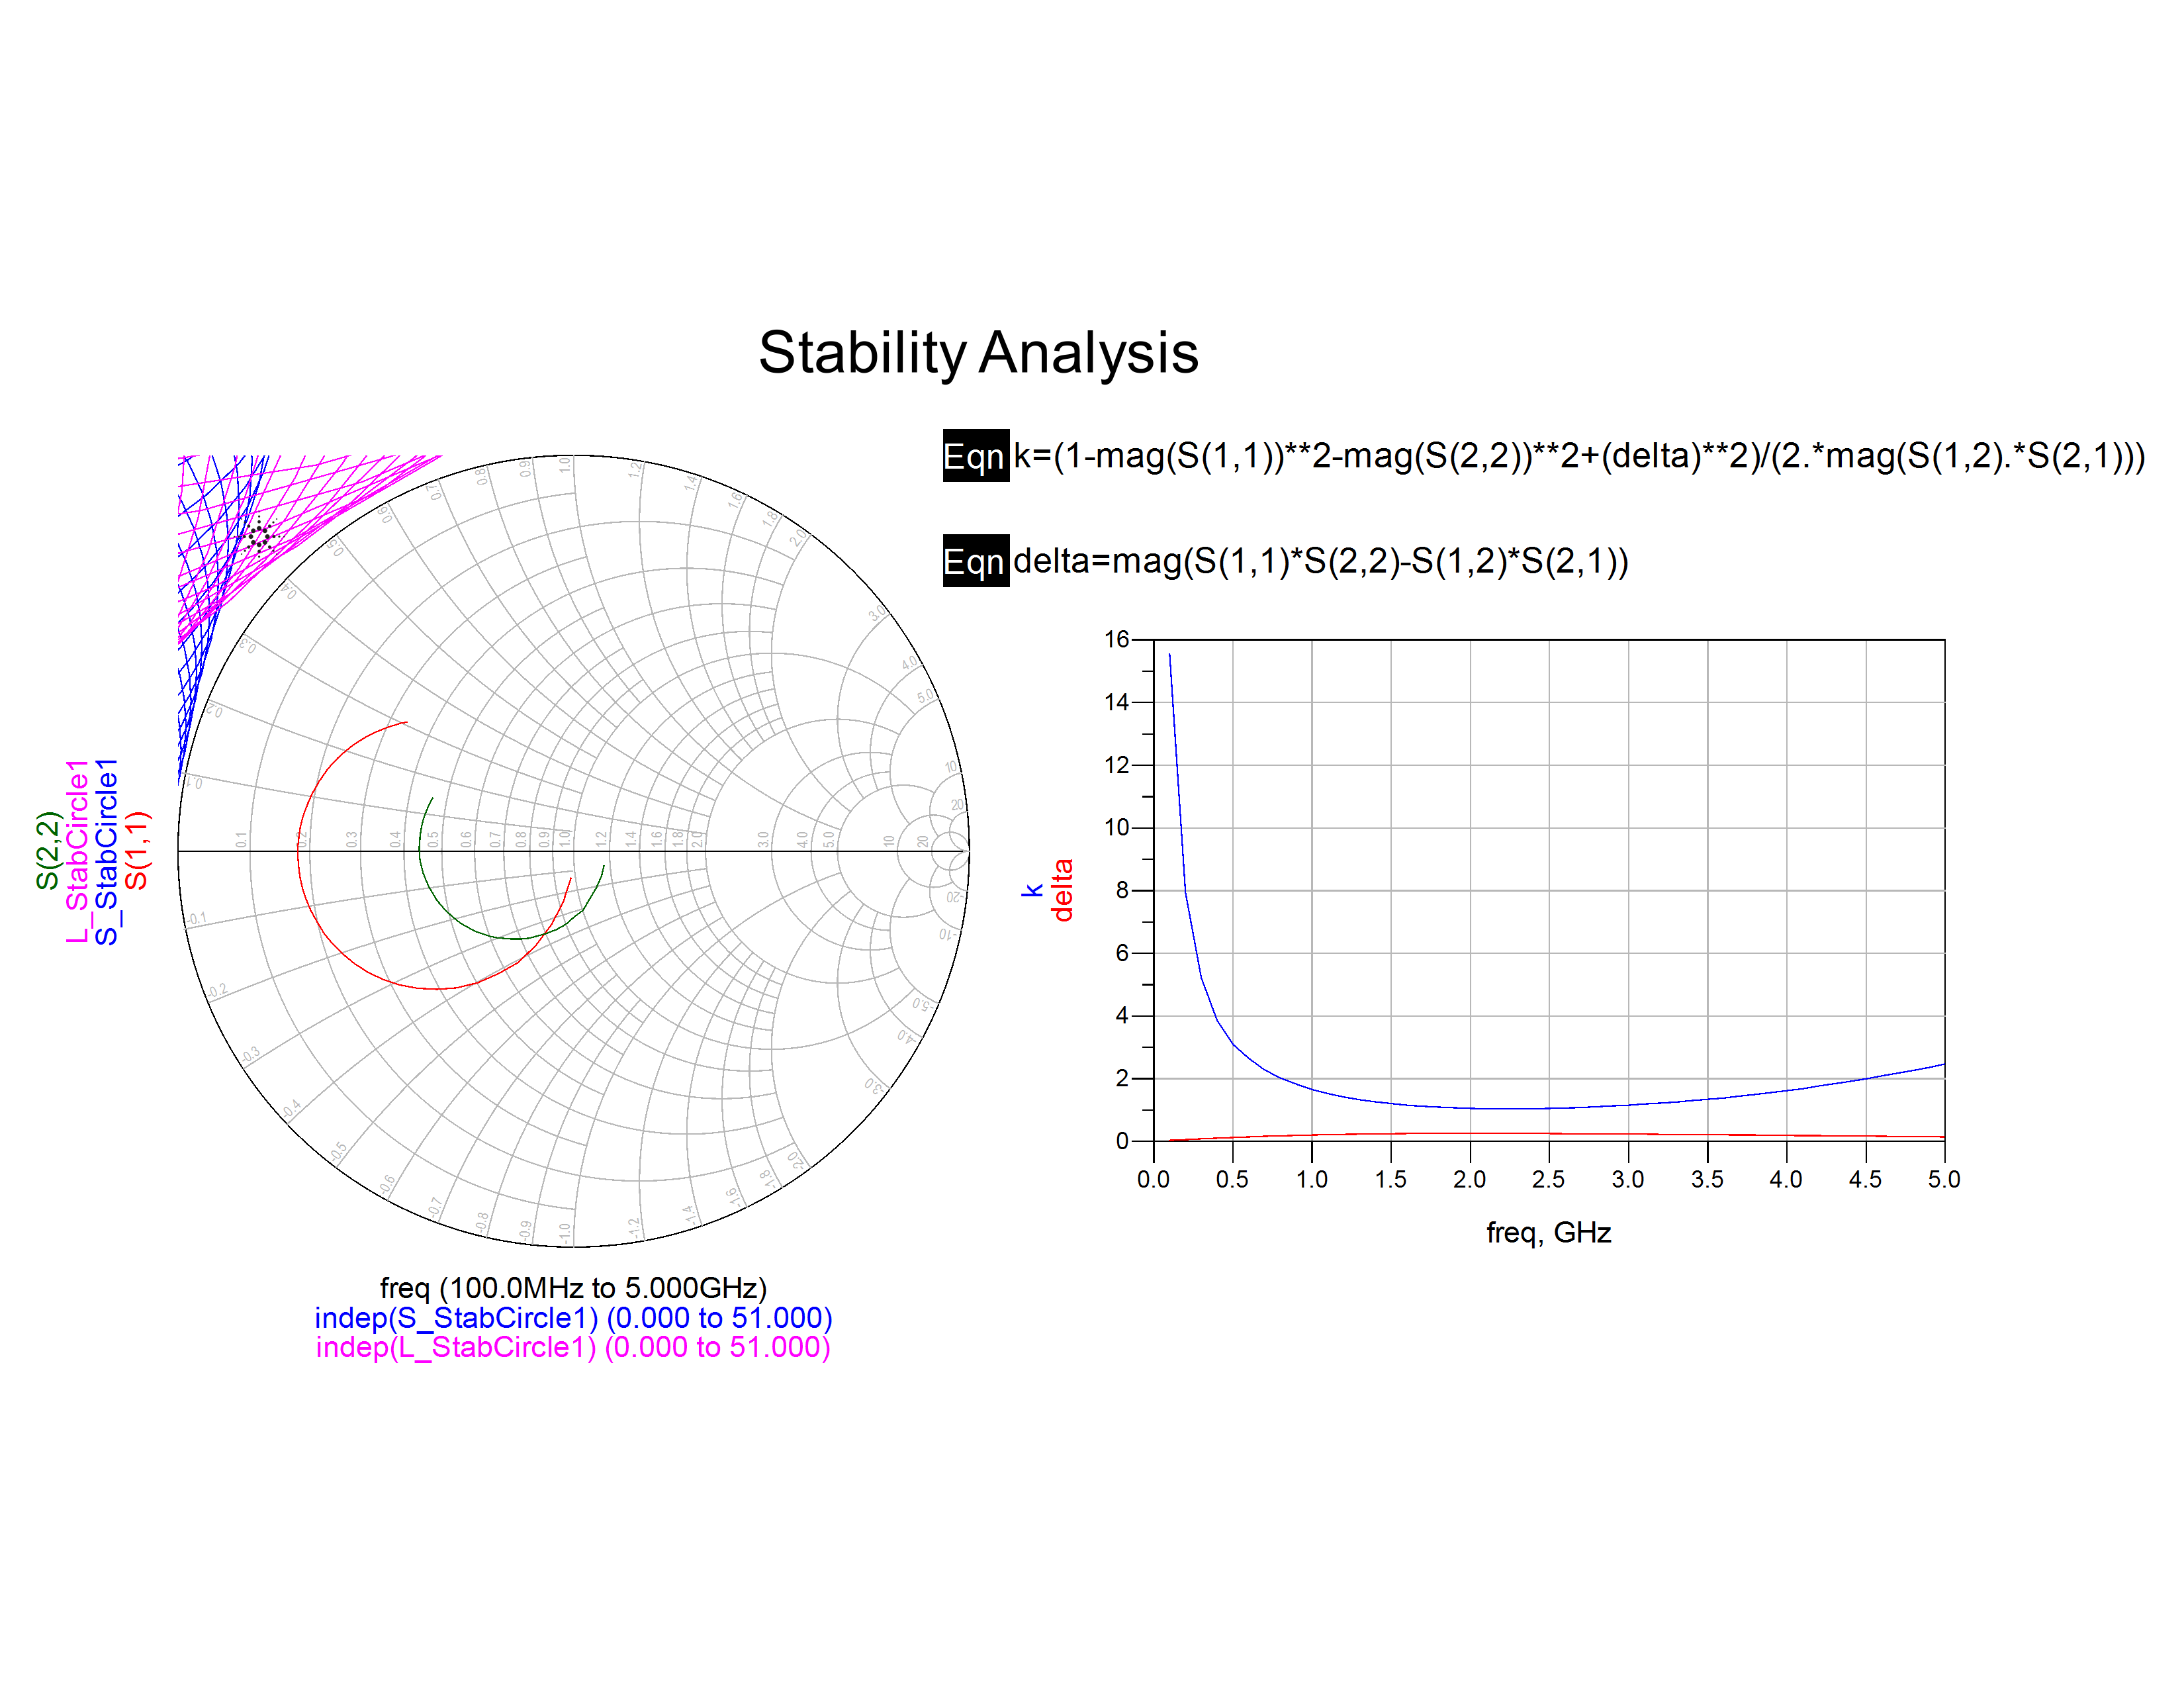

Figure 3 Stability Analysis

Another way to measure stability is by calculating the Rollett stability factor given by the following expressions:

$$k=\frac{1-{|S_{11}|}^{2}-{|S_{22}|}^{2}+{|Δ|}^{2}}{2|S_{21}S_{12}|}>1 \left|Δ\right|=\left|S_{11}S_{22}-S_{12}S_{21}\right|<1$$

As shown in Figure 3 both of these requirements are meet in the given frequency range. With this schematic Simultaneous Conjugate Matching (SCM) and maximum gain is also calculated.

Table 2 Simultaneous Conjugate Matching and maximum gain

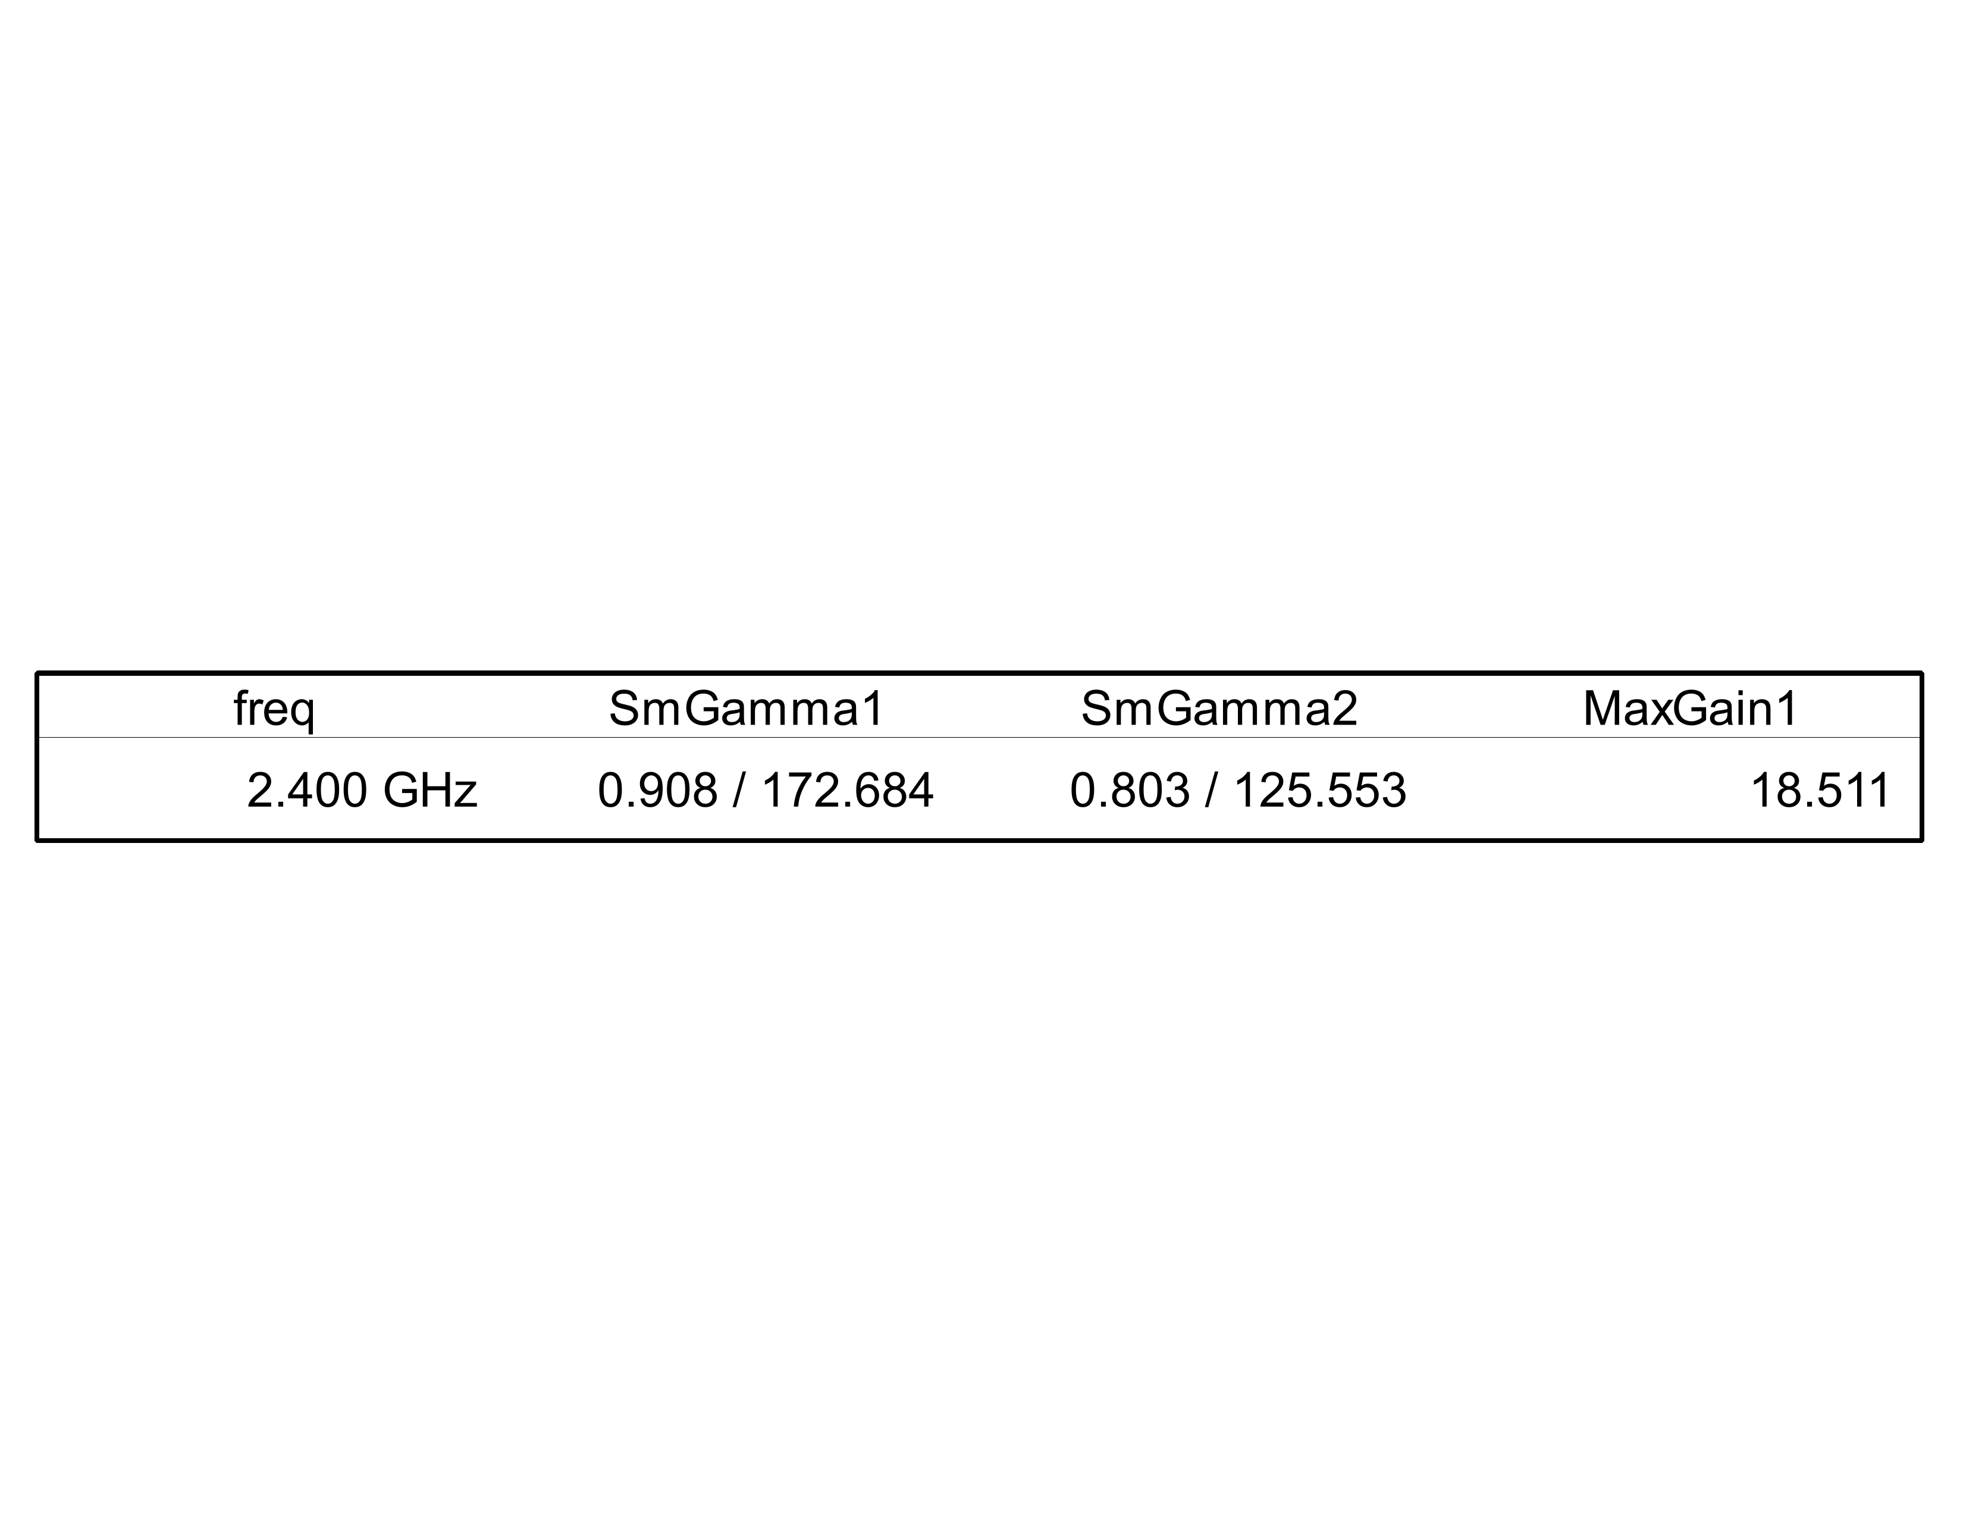

Given the source and load reflection coefficients a matching network can be design to maximize gain.

Designing matching networks

Using ADS Smith chart and LineCalc tools the matching networks were synthesized and simulated. The final schematic is shown below, all of the transmission line dimensions are tabulated in the references section.

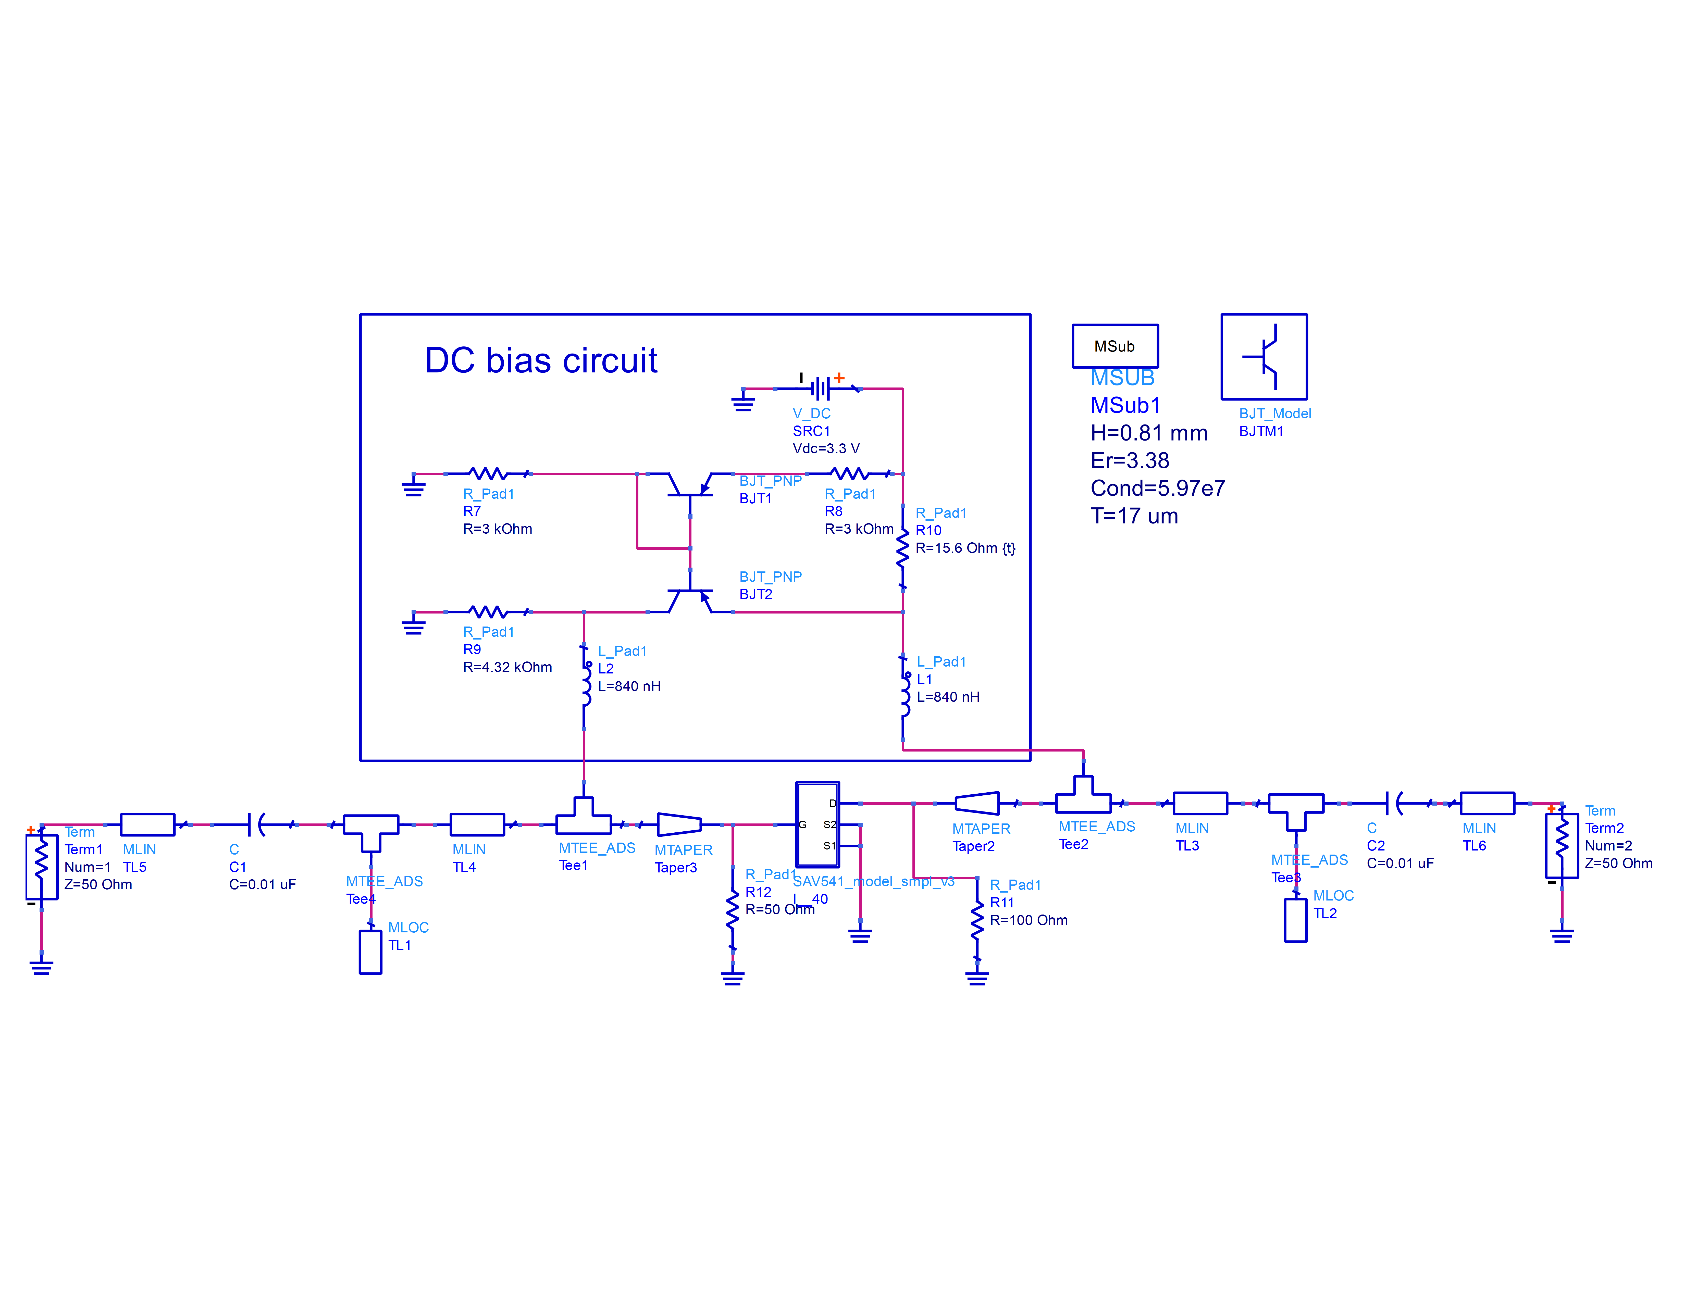

Figure 4 Final design schematic

Figure 4 shows the final design, which was obtained by tuning the different transmission line lengths until satisfactory performance was achieved. Shown below is the performance of the circuit.

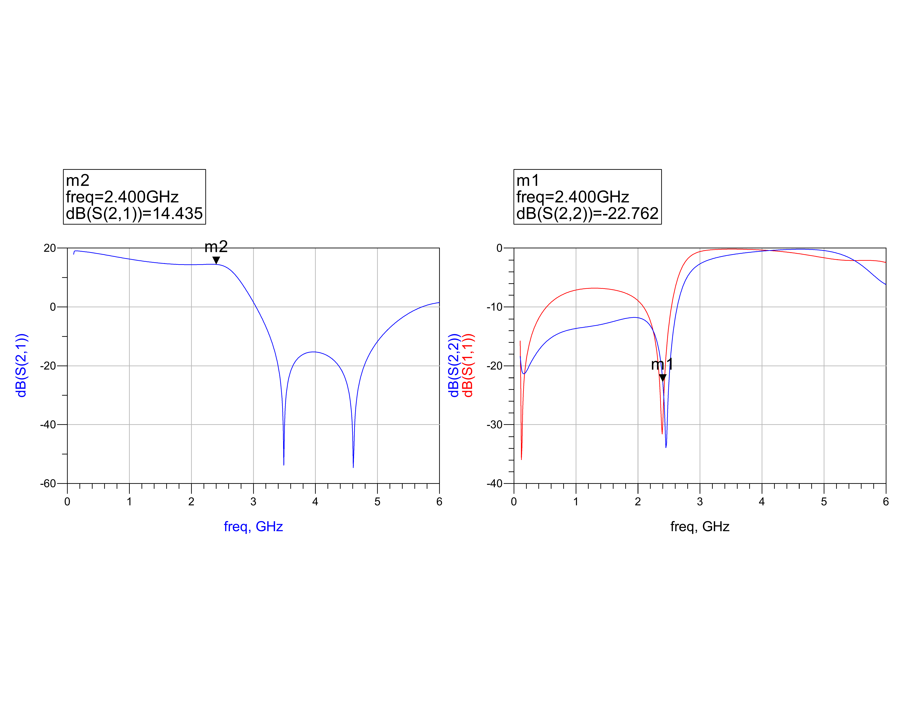

Figure 5 Simulated circuit performance

**Fabrication**

|  |  |
| --- | --- |
| Connectors | SMA, female, gold plated |
| Substrate | Rogers RO4000, εr =3.38  Thickness= 31.25 mils |

**Physical Characteristics** In total we fabricated 5 different designs. Some of the designs work better than the others, some were oscillators. With each iteration we learned how to modify the design for better performance. For layout of the design we used eagle due to the complexity of layout in ADS.

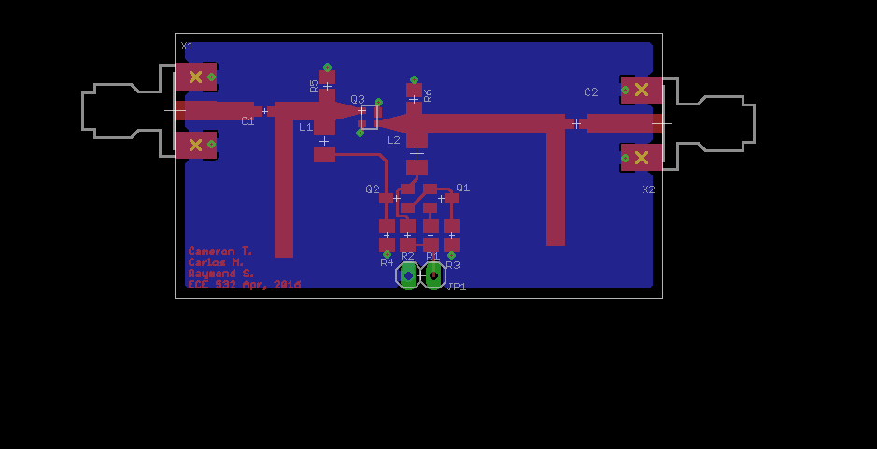

Figure 6 Final design layout

**Measured Results**

I order to obtain the most accurate results we built a TRL calibration kit as shown in Figure 7.

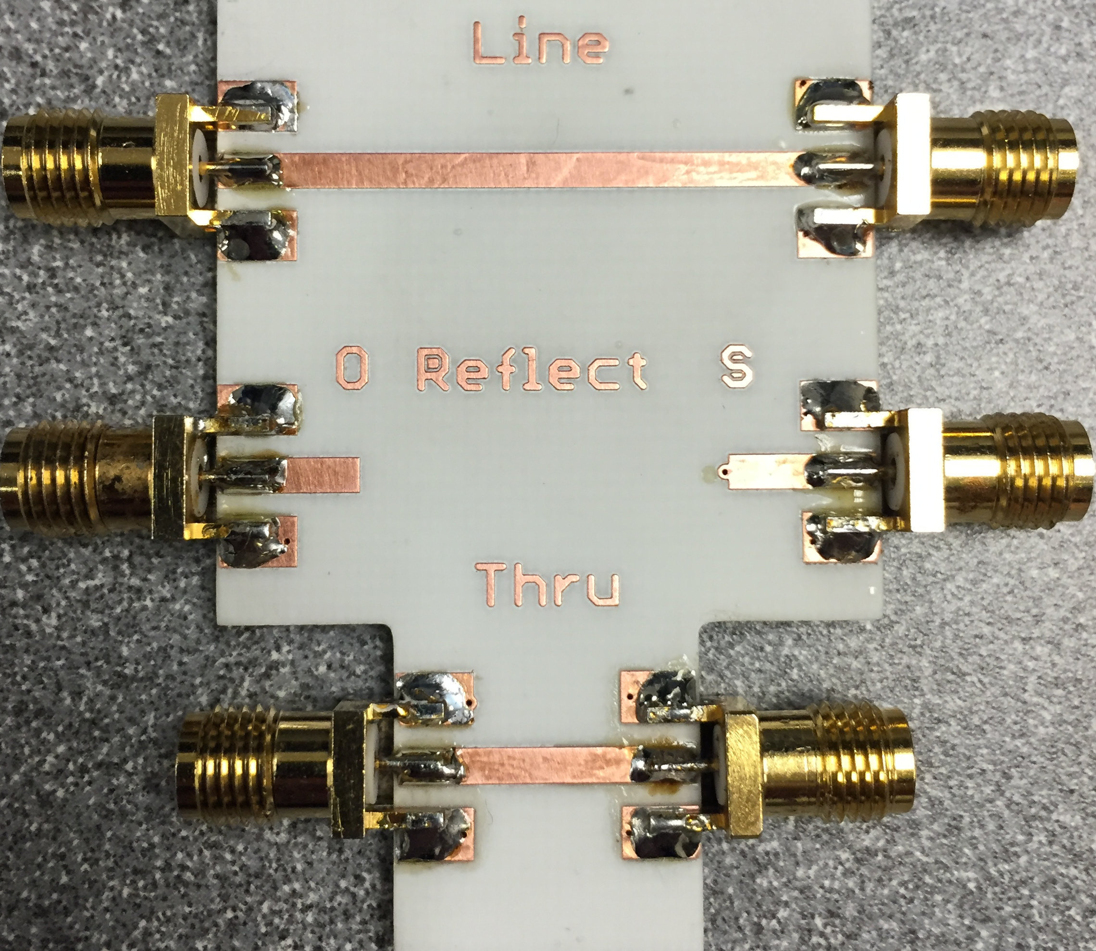

Figure 7 TRL calibration kit

The Figures below show the measured results and comparison plots to simulated performance.

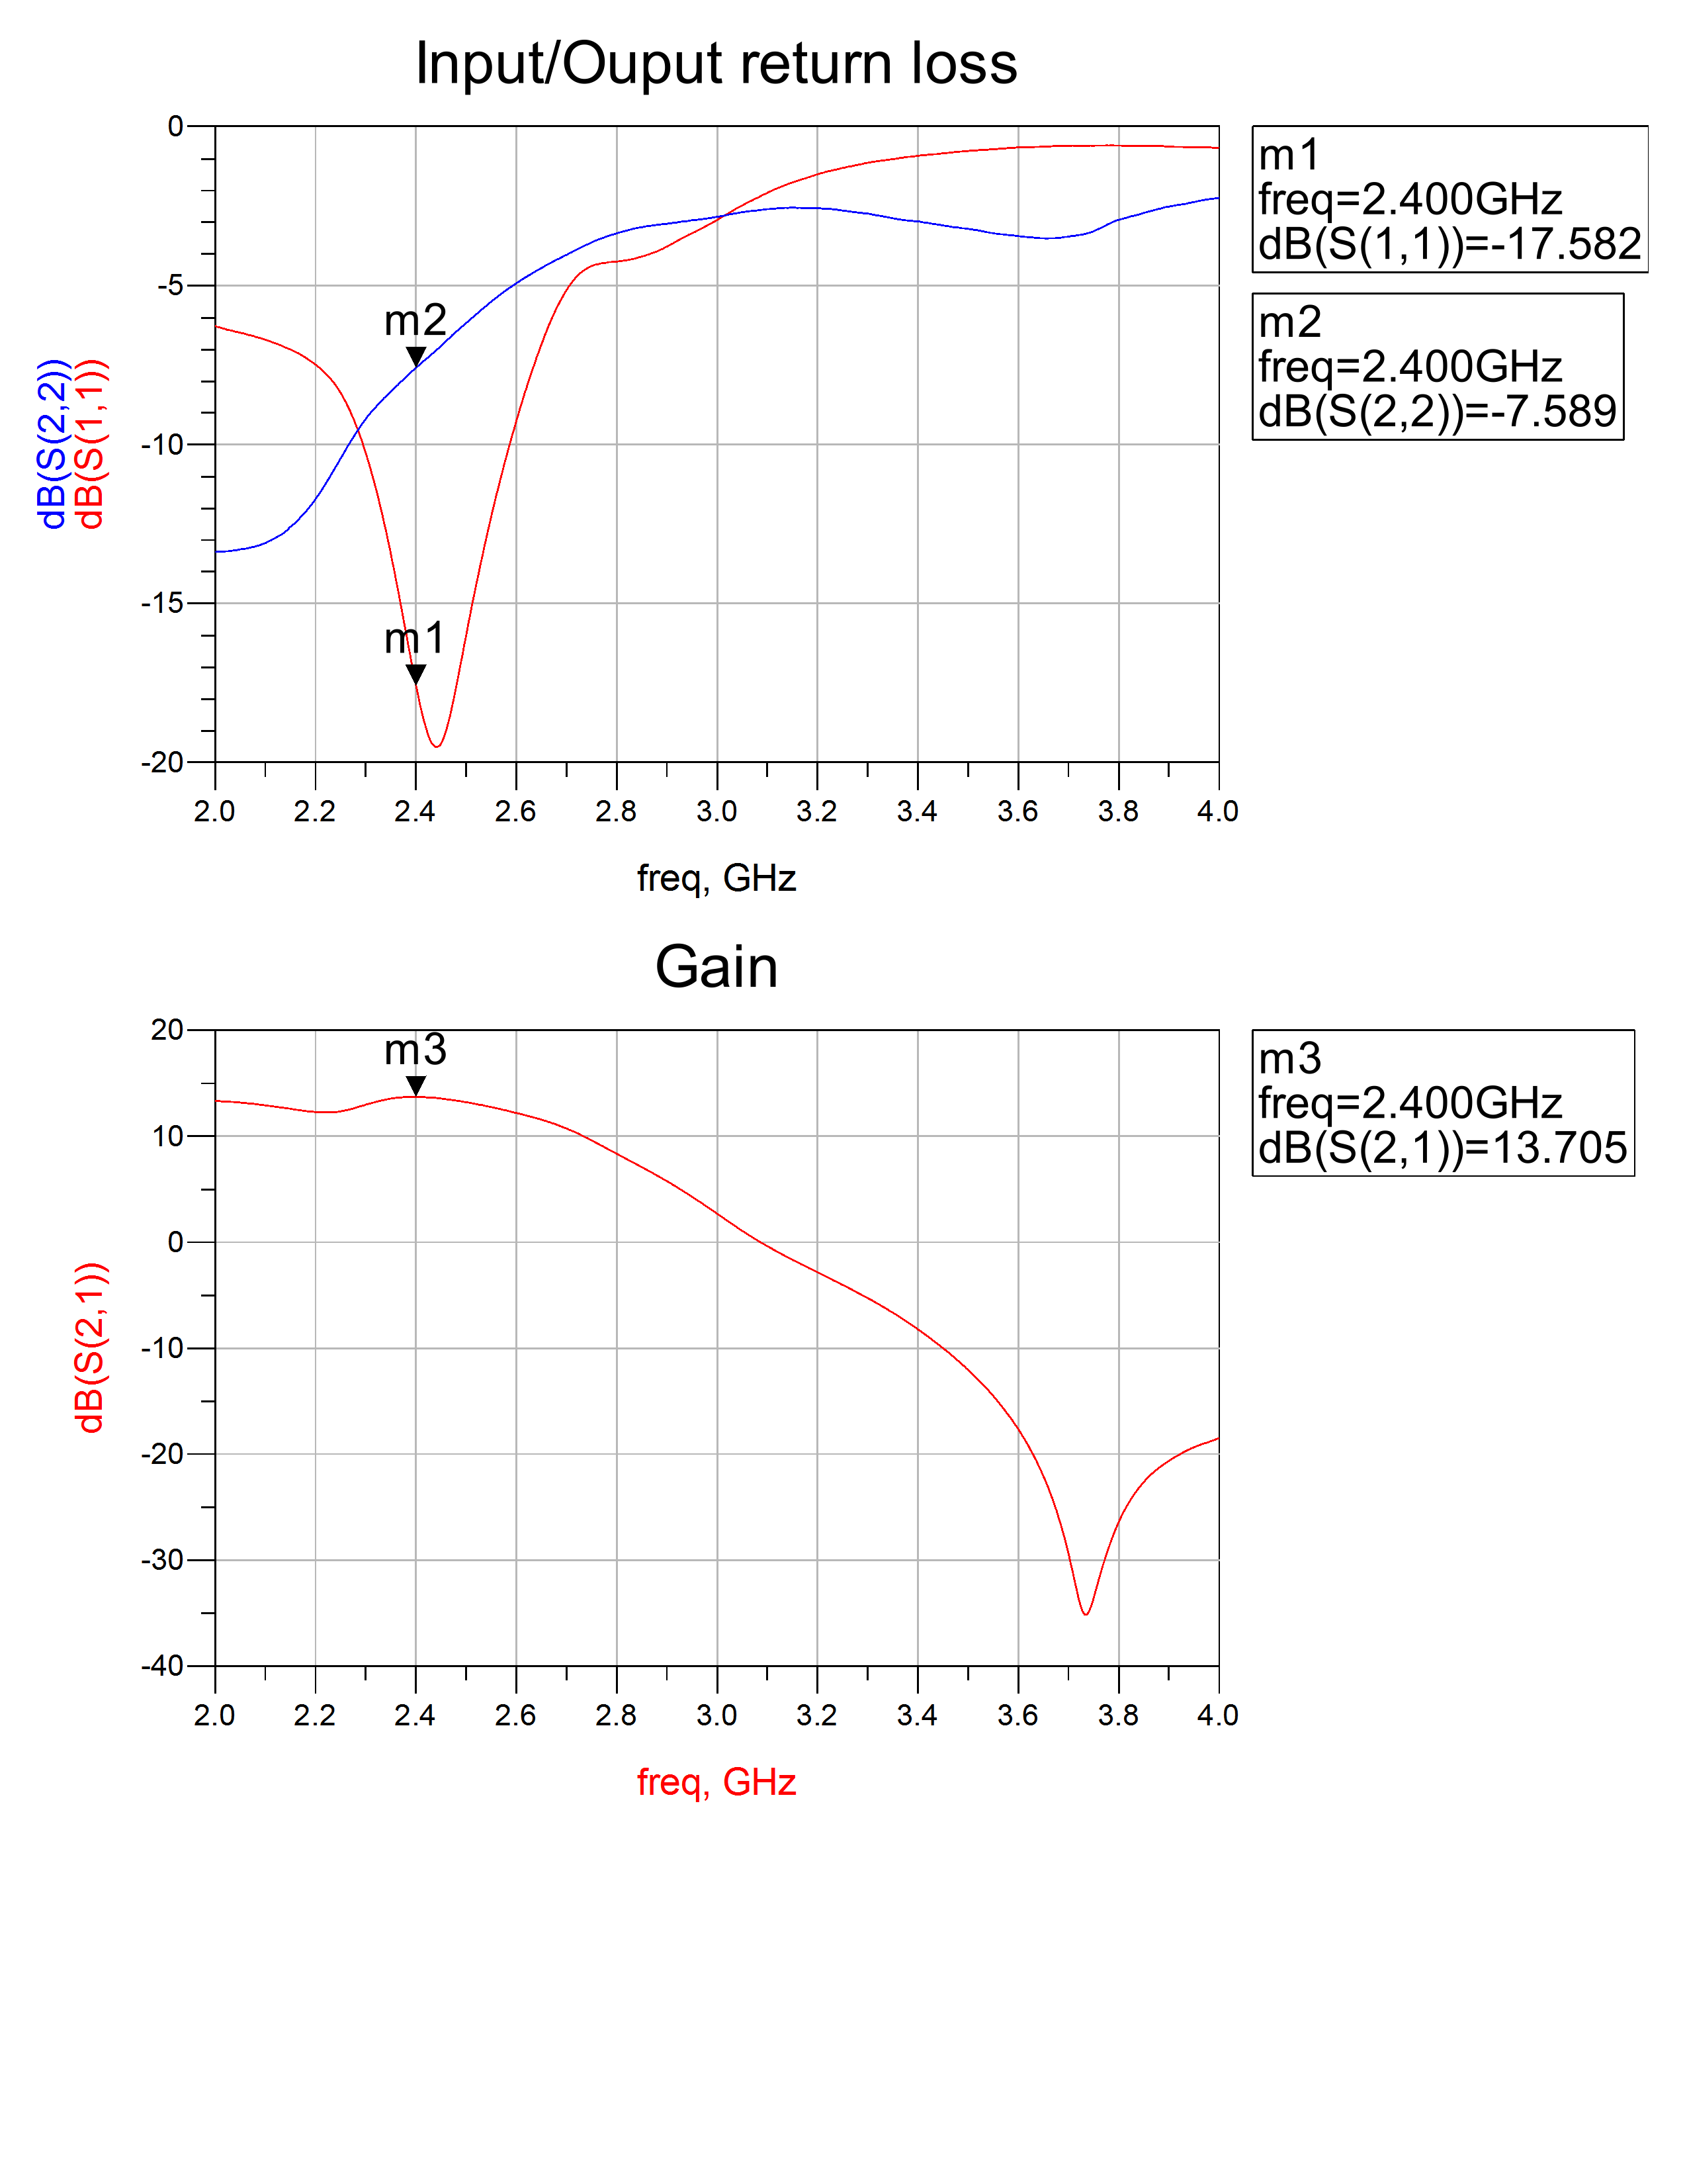

Figure 8 Measured Results

As shown in the figure above we have meet all specifications with the exception of Output return loss. Figure 9 shows a comparison between simulated and measured performance. It can be observed that all performance parameters have are very similar with the exception of Output return loss. At this time we cannot explain this discrepancy.

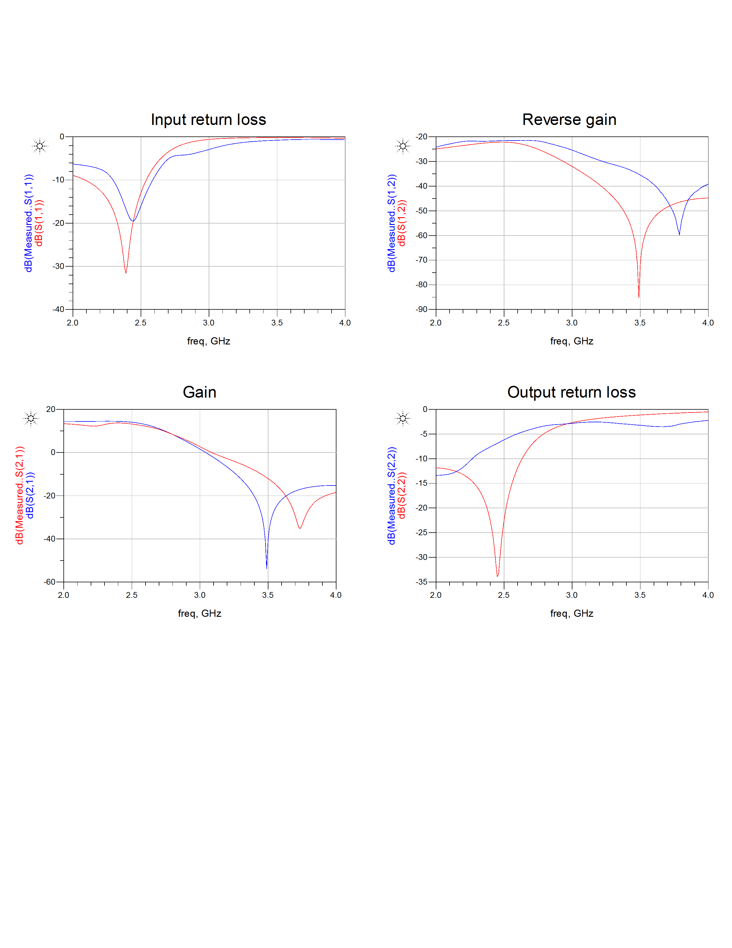

Figure 9 Performance comparison

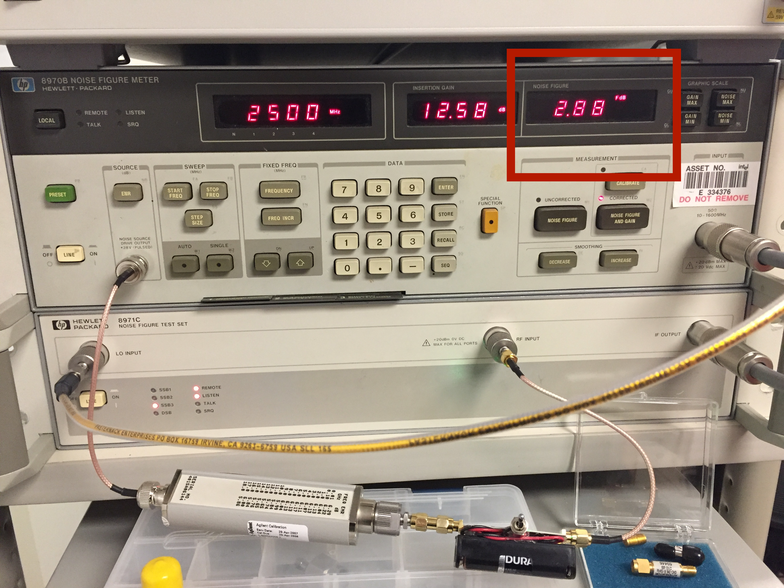

Figure 10 Noise Figure measurement

Completed extra credit

1. Probe station measurements- successfully measured LNA on prove station.
2. Perhaps best performance and artistic impression?

* Battery power
* LED on indicator

**References**

[1]SAV-541+ datasheet https://www.minicircuits.com/pdfs/SAV-541+.pdf

[2]Microwave transistor amplifiers (2nd ed.): analysis and design by Guillermo Gonzales Prentice-Hall, Inc. Upper Saddle River, NJ, USA ©1996

[3] K. Payne, “Practical RF Amplifier Design Using the Available Gain Procedure and the Advanced Design System EM/Circuit Co-Simulation Capability,” Agilent Technologies (5990-3356EN), 2008.

|  |  |  |
| --- | --- | --- |
| Physical Dimensions of final design | | |
| Tran. Line | Width (mm) | Length (mm) |
| TL1 | 1.85 | 13.3 |
| TL2 | 1.85 | 10.06 |
| TL3 | 1.85 | 7.5 |
| TL4 | 1.85 | 2.33 |
| TL5 | 1.85 | 8.04 |
| TL6 | 1.85 | 7.63 |
| Tee1 | 1.85x1.85x1.85 | N/A |
| Tee2 | 1.85x1.85x1.85 | N/A |
| Tee3 | 1.85x1.85x1.85 | N/A |
| Tee4 | 1.85x1.85x1.85 | N/A |
| Tapper1 | w1=1.85 w2=0.4 | 2 |
| Tapper2 | w1=1.85 w2=0.4 | 2 |